GM% and Sales by location

Size of circle stands for sales, Color stands for GM%(Red-High GM%, Green-Low GM%)

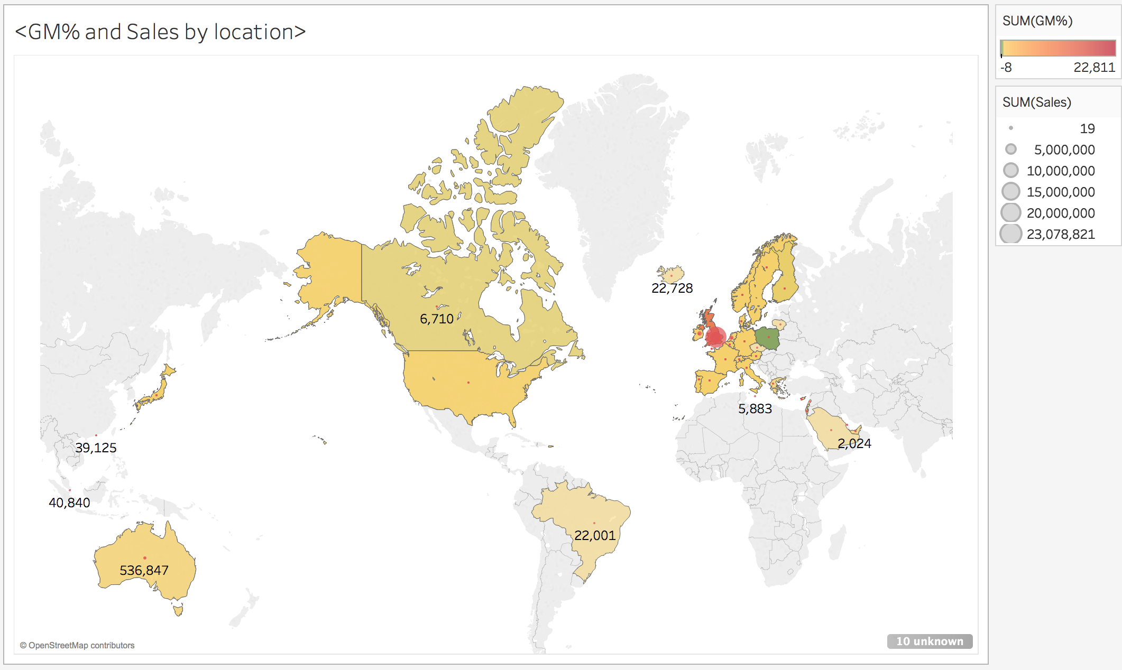

It is seen that most of the sales are from the United Kingdom which is also most profitable

Since customer clusters vary by geography, so I restrict the location to the United Kingdom.

RFM and K-mean for Customer Segmentation

RFM Table

Recency: now – the latest invoice date

Frequency: Number of Invoices

Monetary: SUM(GM%)

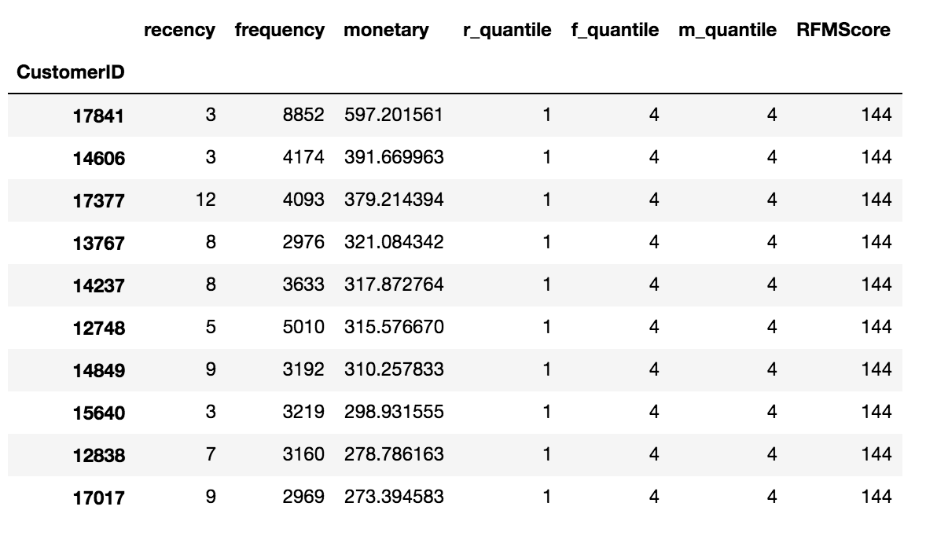

#top 10 customer --- Purchased most recently, Purchased most frequently, Spent most

K-mean Model

Elbow graph ---- 4 clusters

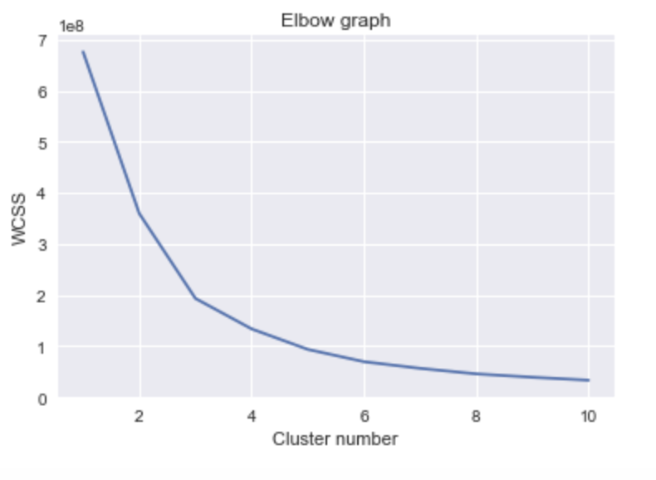

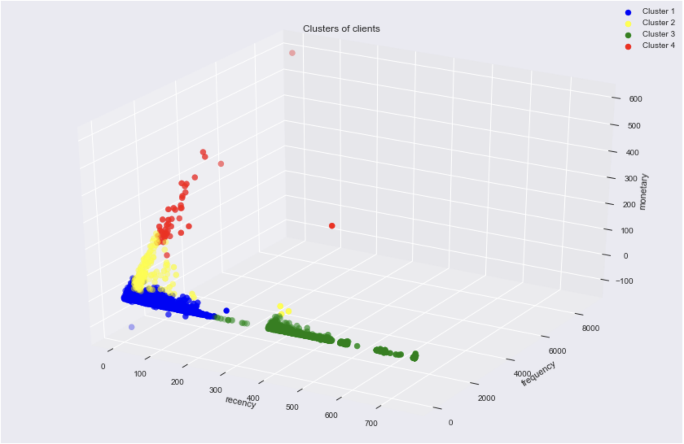

Cluster 1(Red): At Risk

--- Who previously spent much, and made frequent purchase but haven’t purchased for a certain time.

--- Provide time-limited on sale to reconnect them

Cluster 2(Yellow): Loyal Customer

---Customers who bought frequently or recently

---Reward with VIP earned points

Cluster 3(Green): Shopper

---Customers purchased randomly long time ago, low gross margin

---Should not spend too much efforts, since they always look for a good deal

Cluster 4(Blue): Champion

---Most frequency, most recently and most frequently, high gross margin

---Target customers, Main receiver of products promotion

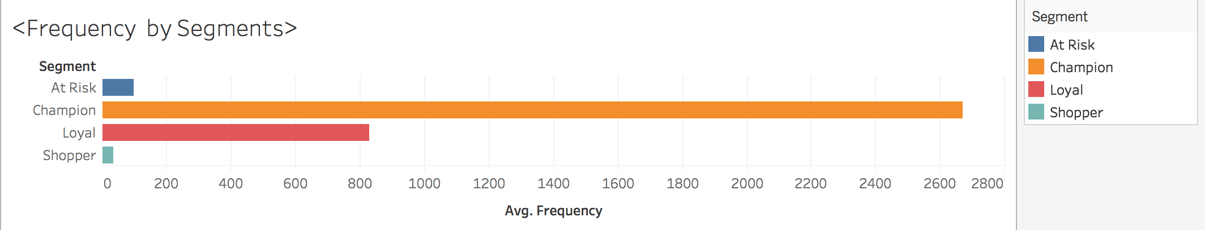

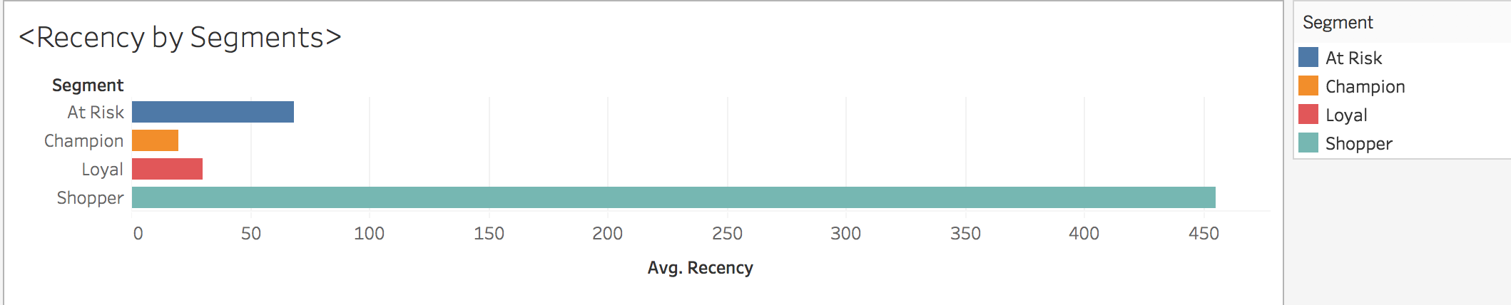

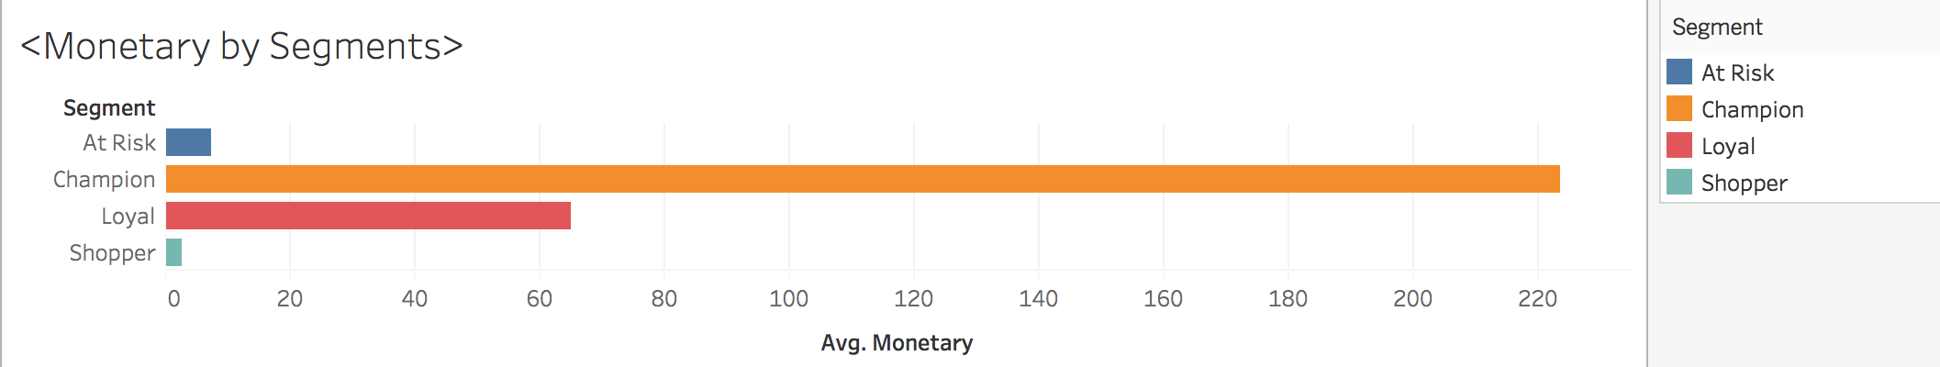

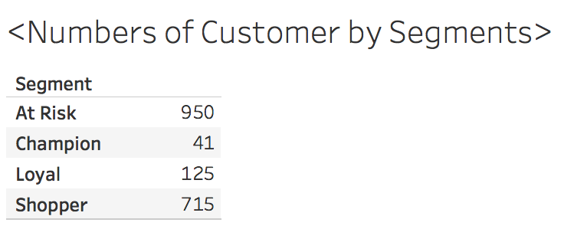

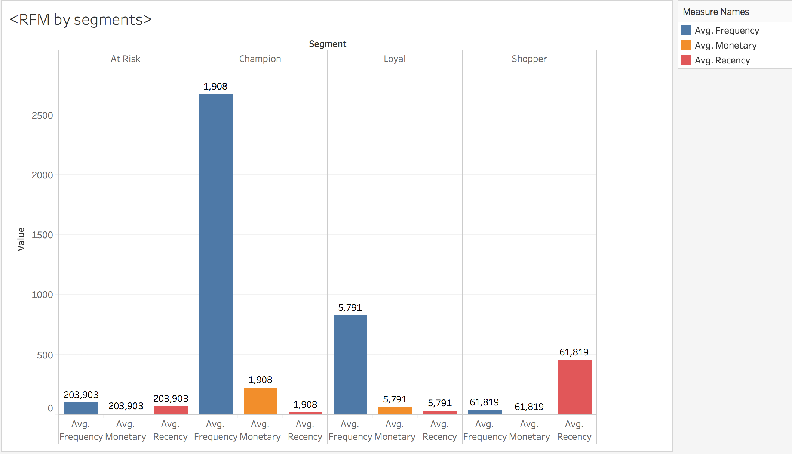

This diagram shows that most of the sales are from shopper and At Risk customer, but both of them could not generate much gross margin for the companies and they are easily leaving since they are more sensitive to price.

Therefore, the company should stop using low pricing strategy to attract those At Risk and Shoppers customers.

Target segmented customers by Region and Profitable

Profitable At_Risk and Shoppers (GM%>0)

Focus on At Risk customers in North, South and West; Shopper in Central, North and South

Unprofitable Champion and Loyal customer(GM%<0)

Focus on Champion customers in North and South; Loyal customer in West, and find out the reasons of their negative GM%

